BYOxLink - How to guide

Use guest Wi-Fi service to connect students’ Windows devices
This document explains how a student can connect a Windows device to the school guest Wi-Fi network (EQGUEST) so staff can then complete the Intune enrolment on their device.
The guest Wi-Fi connection is limited and only lasts for eight hours. You may not be able to access some resources such as shared network drives, printers or local school websites through the guest Wi-Fi.
Note: Sign on will only work with a valid school email address i.e. username>@eq.edu.au. You should use your existing school EQ email address.

Step 1. Select the Guest Wi-Fi network
- Select the  Wi-Fi icon at the bottom right of the screen.
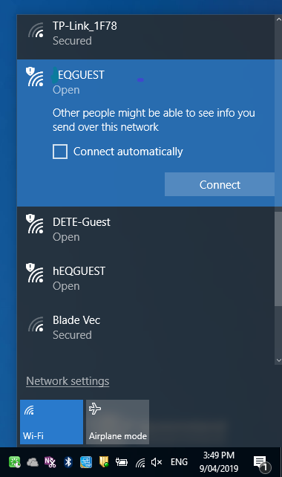
- Scroll the Wi-Fi networks to select EQGUEST. Select Connect.
Step 1b
Step 1a

Step 2. Sign on to the Guest Wi-Fi network
- A Sign on page will be displayed
- Enter your EQ email address and password
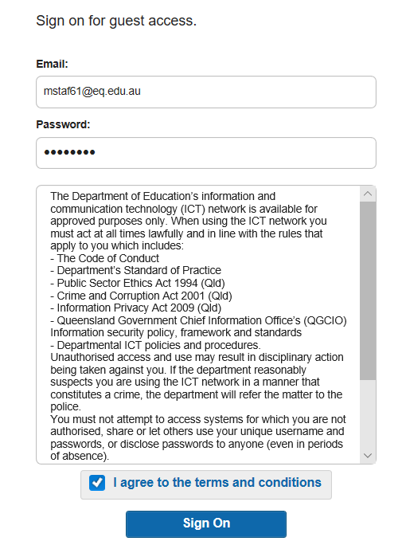
- Read and accept the Acceptable Use Policy by ticking the box
- Select Sign On.

- A success screen will display, close the window.
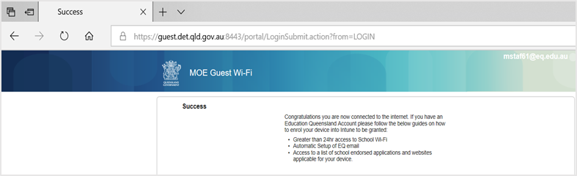

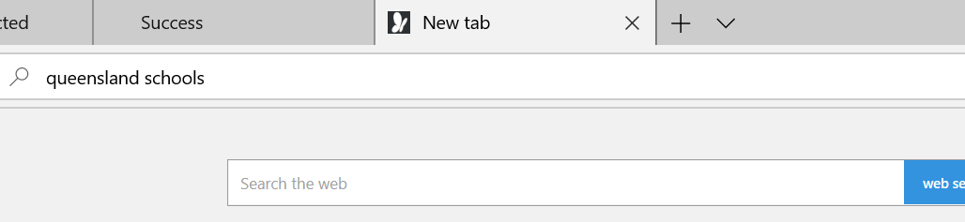
- Select a new tab in your browser and type a search in the search bar e.g. Queensland schools.

- You will be prompted to enter your EQ username and password. Ensure only the first part of your EQ email address is entered e.g. mstaf61. Type your password. Select OK.
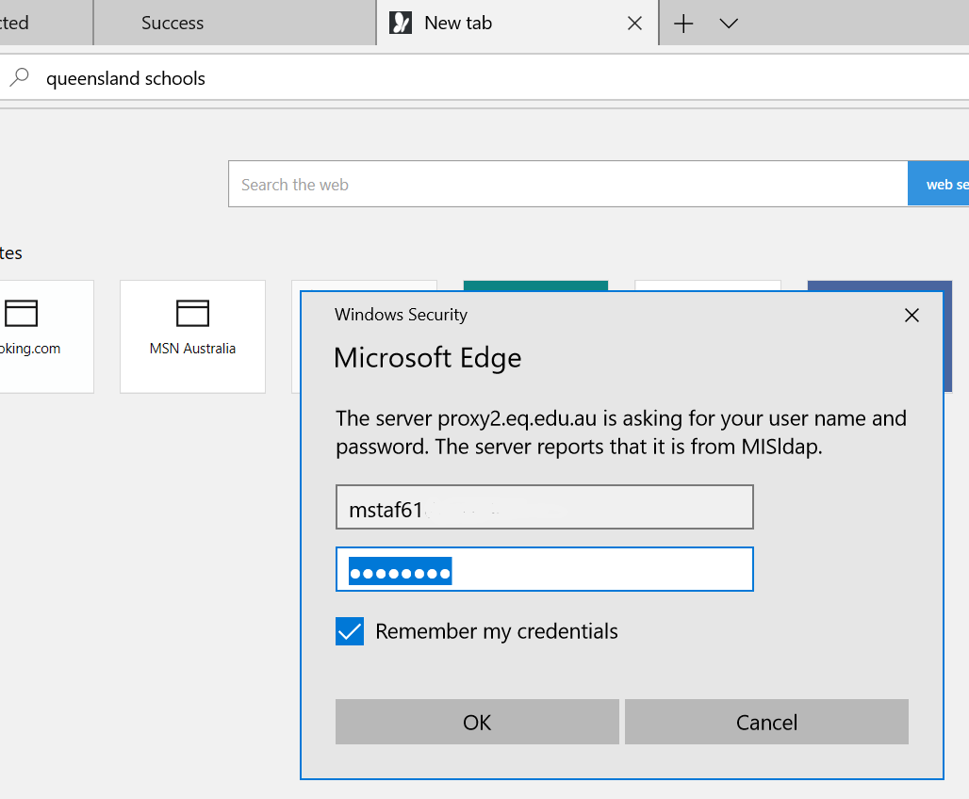
Note: Use the first part of your EQ email address

- If your internet is not working, contact your school IT support staff for assistance.

Step 3. Next steps
To access school email, learning applications, printers and shared network drives, you will need to enrol your device into Microsoft Intune. Refer to
How to guide – Enrol your BYO Windows device into Intune or
Intune installation video for Windows devices
to complete this process.

